QUESTIONS(Programs):
-----------------
QUESTION 1:
------------
Project :EmployeeDetails
Package :org.emp
Class :Employee
Methods :empId(),empName(),empDob(),empPhone(),empEmail(),empAddress()

Description:
Create an object for employee class and call above methods also follow the all coding standards.

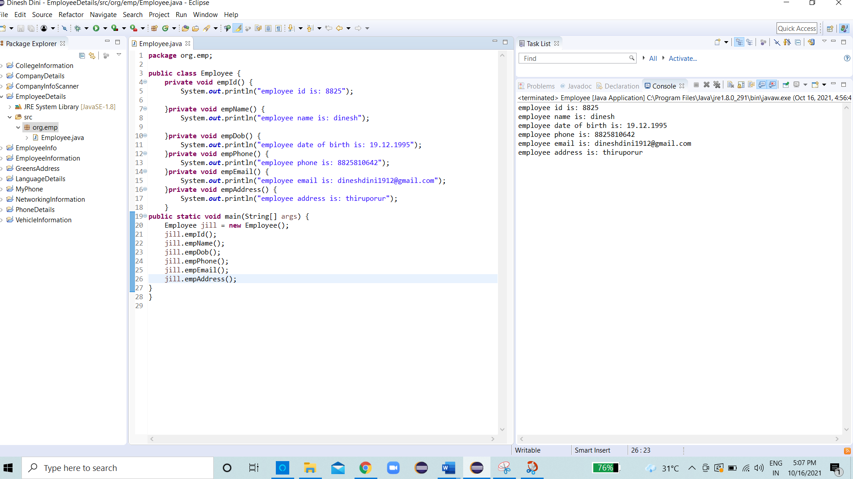

QUESTION 2:
-------------
Project :GreensAddress
Package :org.add
Class :GreensTech
Methods :greensOmr(),greensAdayar(),greensTambaram(),greensVelacherry(),greensAnnaNagar()

Description:
Create an object for GreensTech class and call above methods also follow the all coding standards.

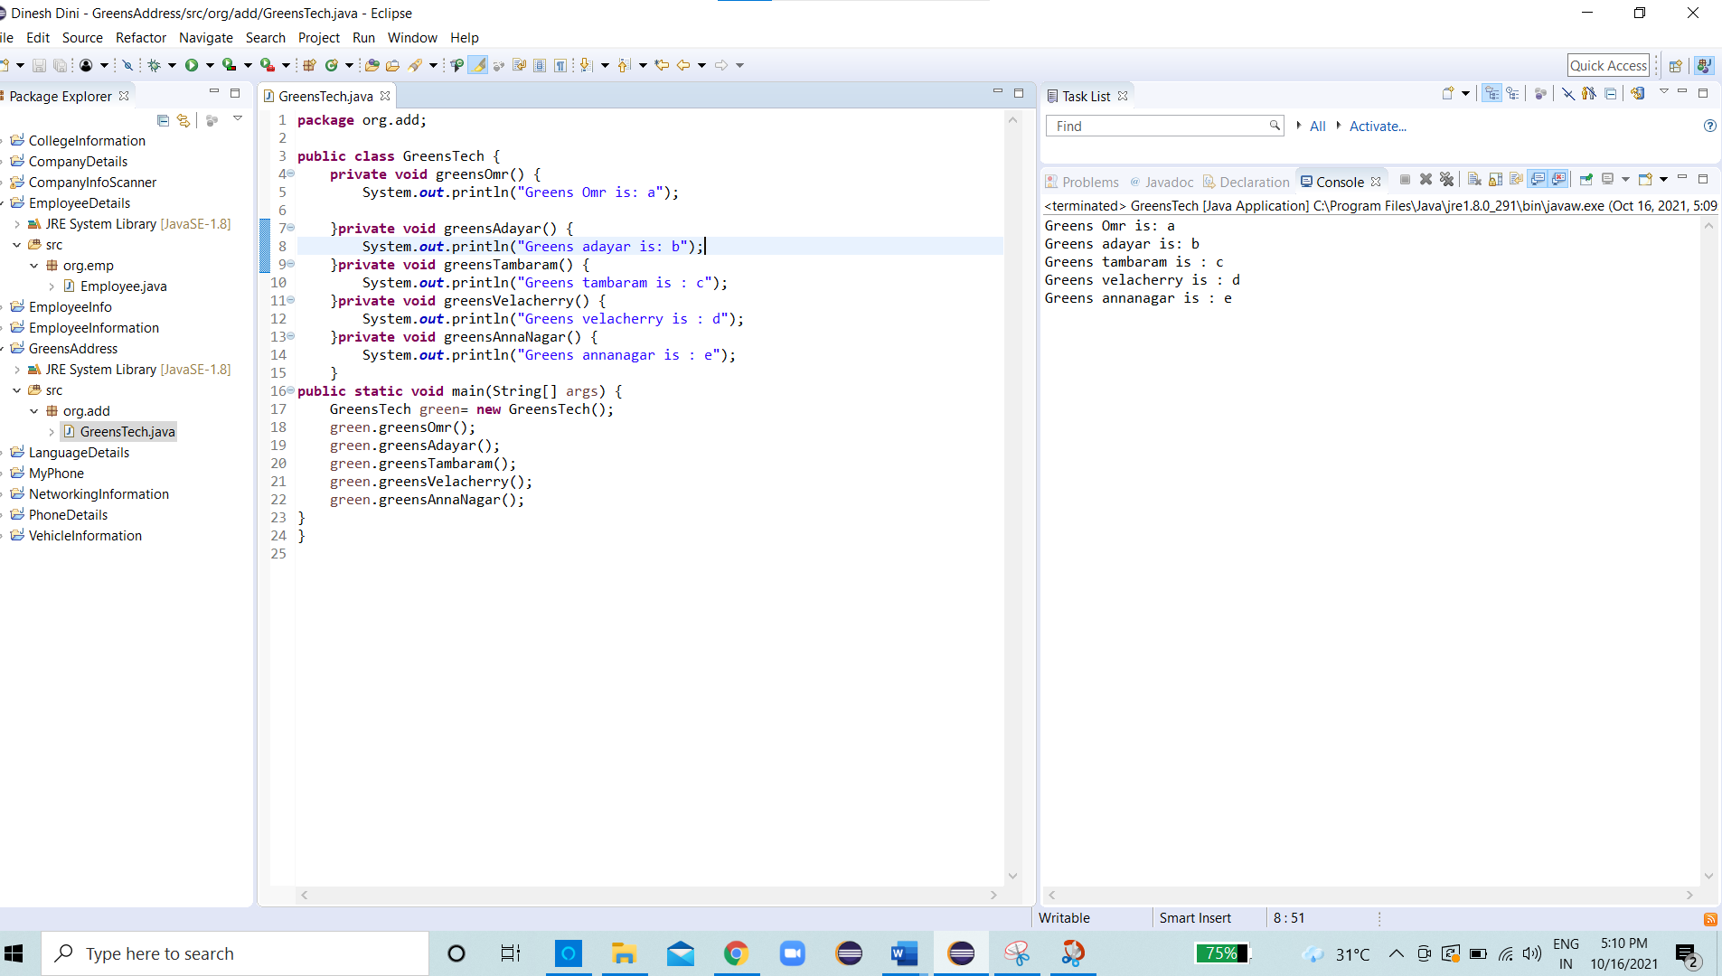

QUESTION 3:
------------
Project :CompanyDetails
Package :org.company
Class :CompanyInfo
Methods :companyName(),companyId(),companyAddress()

Description:
Create an object for CompanyDetails class and call above methods also follow the all coding standards.

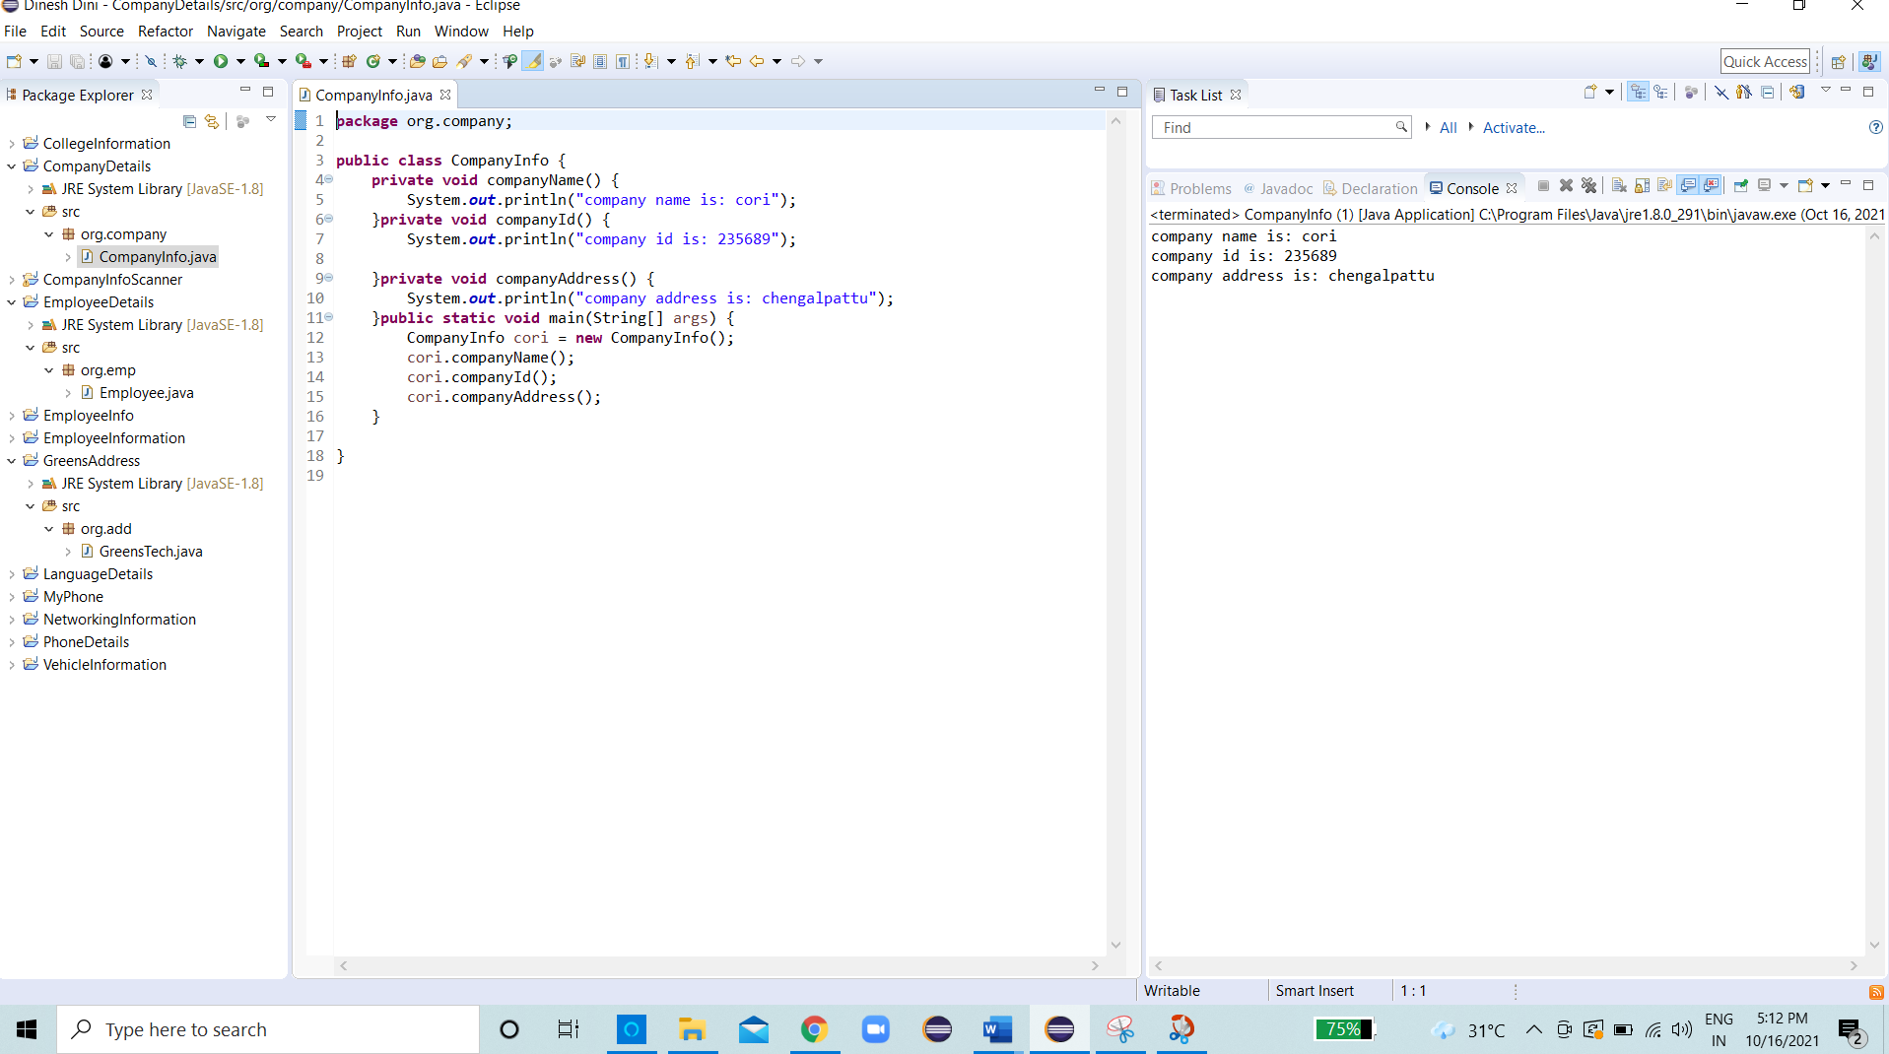

QUESTION 4:
-----------
Project :MyPhone
Package :org.phone
Class :PhoneInfo
Methods :phoneName(),phoneMieiNum(),Camera(),storage(),osName()

Description:
Create an object for PhoneInfo class and call above methods also follow the all coding standards.

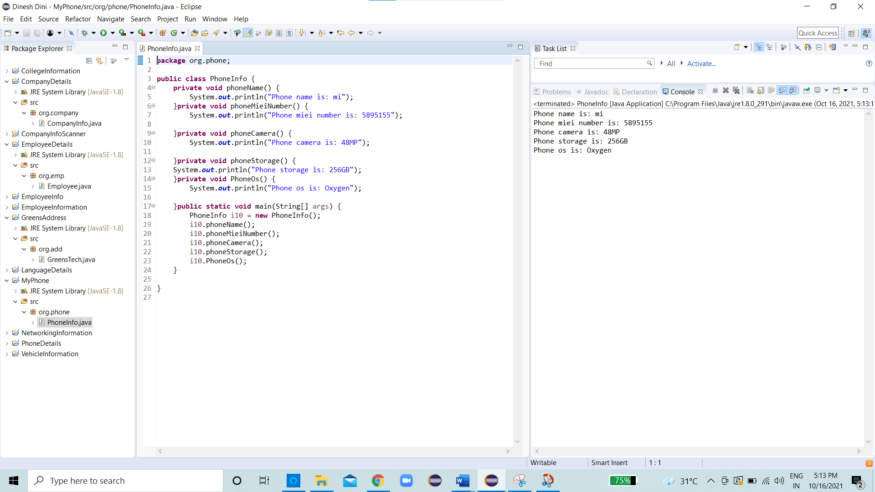
QUESTION 5:
------------
Project :LanguageDetails
Package :org.lang

Class :LanguageInfo
Methods :tamilLanguage(),englishLanguage(),hindiLanguage()

Class :StateDetails
Methods :southIndia(),northIndia()

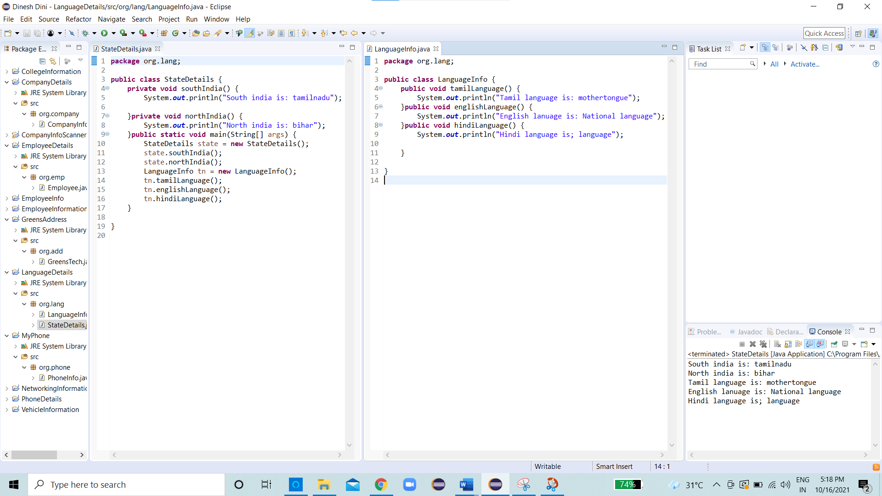

Description:
Create an object for LanguageInfo and StateDetails inside the StateDetails class and call both classes methods also follow the all coding standards.

QUESTION 6:
-----------
Project :EmployeeInformation
Package :org.emp
Class :Employee
Methods :empName()

Package :org.company
Class :Company
Methods :companyName()

Package :org.client
Class :Client
Methods :clientName()

Package :org.project
Class :Project
Methods :projectName()

Description:
Create an object for all 4 classes inside the Employee class and call all classes methods also follow the all coding standards.
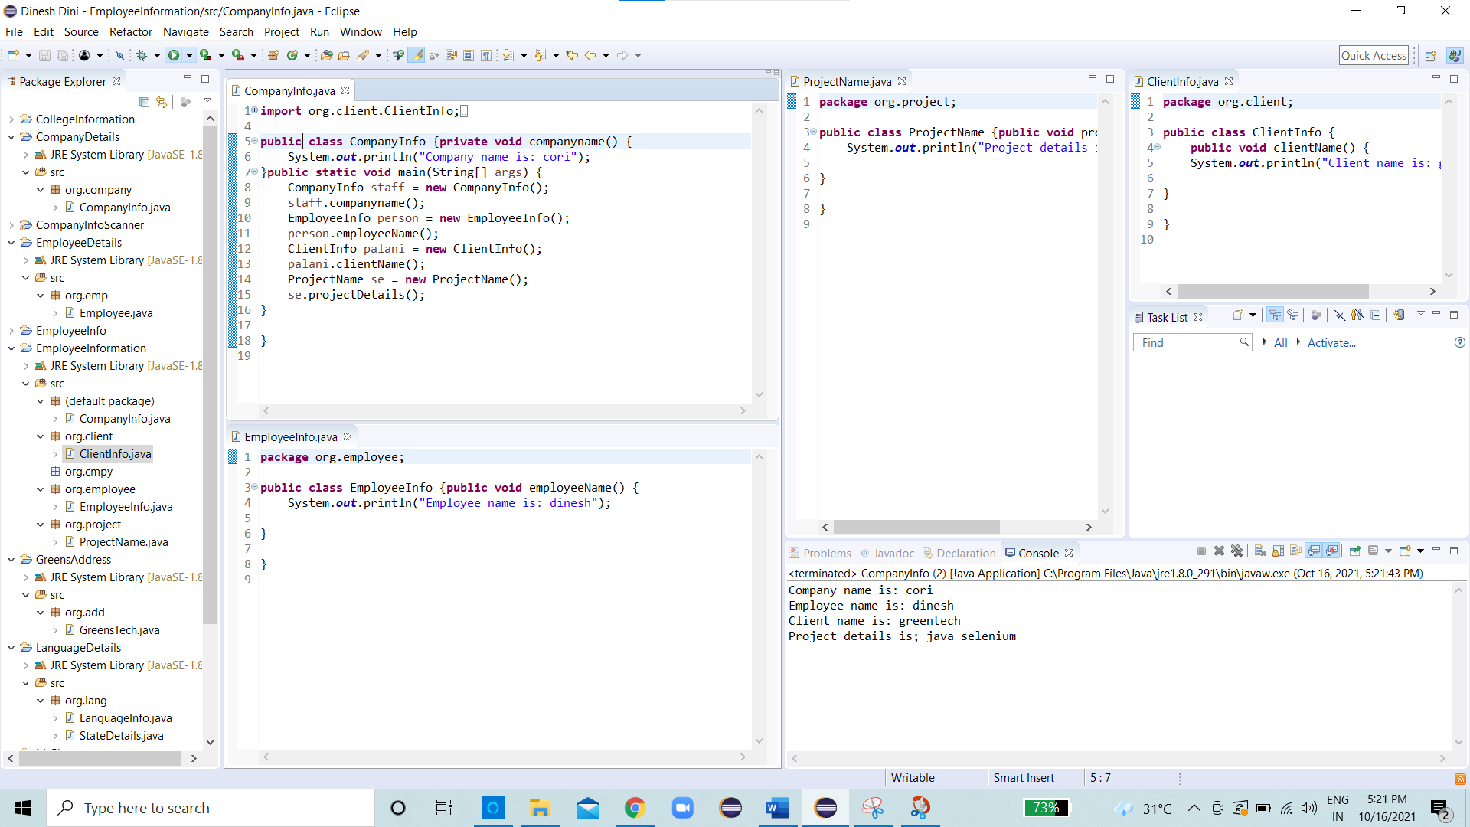

QUESTION 7:
-------------
Project :PhoneDetails
Package :org.phone
Class :ExternalStorage
Methods :size()

Class :InternalStorage
Methods :processorName(),ramSize()

Description:
Create an object for ExternalStorage and InternalStorage inside the InternalStorage class and call both classes methods also follow the all coding standards.
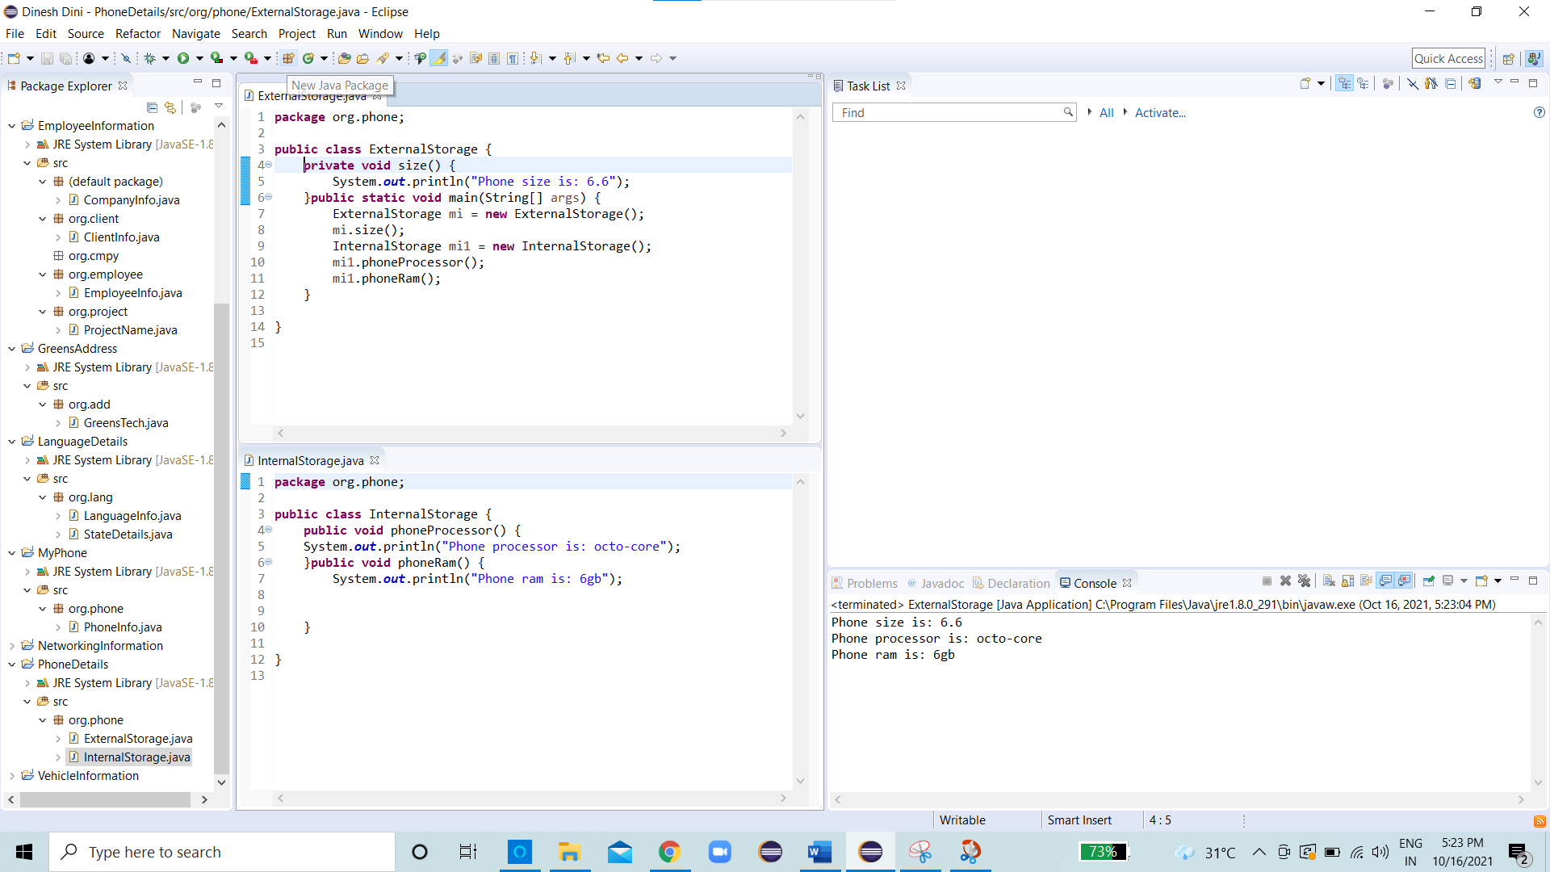

QUESTION 8:
------------
Project :CollegeInformation
Package :org.college
Class :College
Methods :collegeName(),collegeCode(),collegeRank()

Class :Student
Methods :studentName(),studentDept(),studentId()

Class :Hostel
Methods :hostelName()

Class :Dept
Methods :deptName()

Description:
Create an object for all 4 classes inside the College class and call all classes methods also follow the all coding standards.
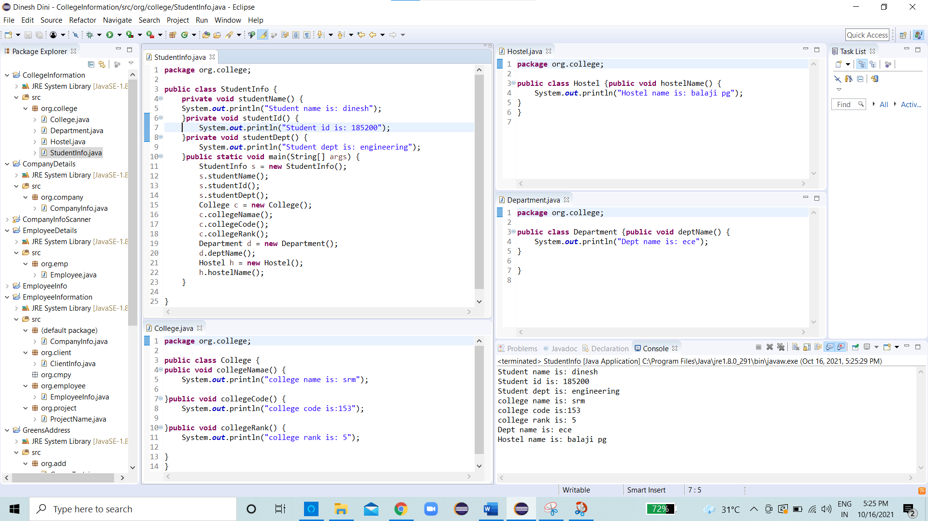

QUESTION 9:
------------
Project :VehicleInformation
Package :org.allvehicle
Class :Vehicle
Methods :VehicleNecessery()

Package :org.twowheeler
Class :TwoWheller
Methods :bike(),cycle()

Package :org.threewheeler
Class :ThreeWheeler
Methods :Auto()

Package :org.fourwheeler
Class :FourWheeler
Methods :car(),bus(),lorry()

Description:
Create an object for all 4 classes inside the Vehicle class and call all classes methods also follow the all coding standards.
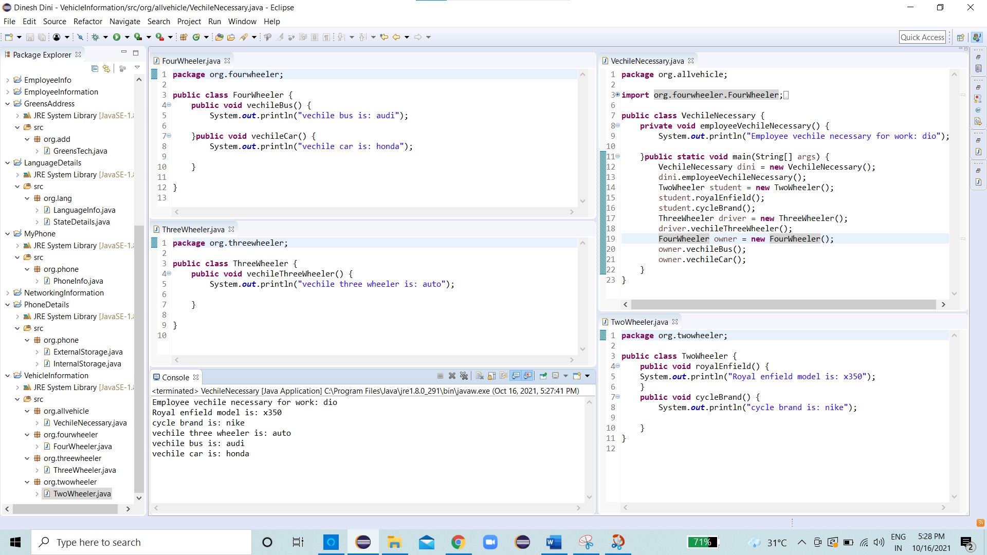

QUESTION 10:
--------------
Project :TransportInformation
Package :org.transport
Class :Transport
Methods :TransportForm

Package :org.road
Class :Road
Methods :bike(),cycle(),bus(),car()

Package :org.air
Class :Air
Methods :aeroPlane(),heliCopter()

Package :org.water
Class :Water
Methods :boat(),ship()

Description:
Create an object for all 4 classes inside the Transport class and call all classes methods also follow the all coding standards.
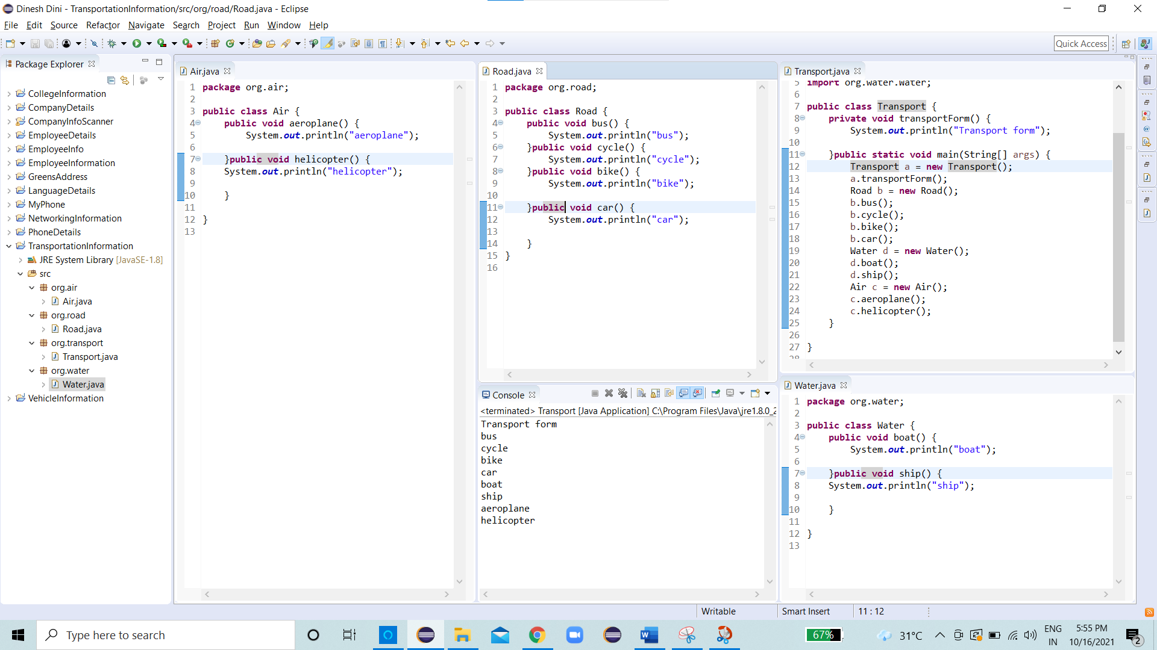

QUESTION 11:
--------------
Project :NetworkInformation
Package :org.network
Class :Wifi
Methods :wifiName()

Class :MobileData
Methods :dataName()

Class :Lan
Methods :lanName()

Class :Wireless
Methods :modamName()

Description:
Create an object for all 4 classes inside the Wifi class and call all classes methods also follow the all coding standards.
